| **Test Plan**  **Project -** SnapDeal E-Commerce Testing |
| --- |

| INTRODUCTION |
| --- |

This document defines the test plan for validating the core functionalities of the SnapDeal e-commerce platform. The objective is to ensure that the website provides a smooth, secure, and error-free user experience across features such as product search, category browsing, filters, cart management, checkout simulation, and user account functionality. Testing will be conducted using the Cypress automation framework following the Page Object Model (POM) approach.

AUT-https://www.snapdeal.com/

| OBJECTIVE |
| --- |

To test the SnapDeal website for the following:  
 ● Accurate search results and category navigation.  
 ● Effective filter application (brand, price, size, etc.).  
 ● Correct display of product details and add-to-cart functionality.  
 ● Cart item management and pricing accuracy.  
 ● Simulated checkout flow and validation.  
 ● User login/signup and profile functionality.  
 ● UI responsiveness across devices and browsers.

#### 

| SCOPE |
| --- |

● **In-Scope**

1. Functional testing of search, filters, product, cart, checkout, and login.
2. UI validation and usability checks.
3. Cross-browser testing.
4. Responsive testing on desktop and mobile views.
5. Boundary and negative testing for inputs.

● **Out of Scope**

1. Performance testing
2. Forgot Password, Signup
3. Live payment gateway.
4. Email/SMS verification.
5. 3rd-party integrations like payment APIs.

| **Testable Features** |
| --- |

● Search bar input and suggestions.  
 ● Category navigation via menus.  
 ● Filter functionality (brand, price, discount, size).  
 ● Product detail pages (price, description, size, etc.).  
 ● Add to Cart, quantity update, and remove item.  
 ● Login, Signup, and Profile management.  
 ● Responsive UI design.

**Page Object Model (POM) Structure.**

Create Page Object classes for key pages:  
 ● Home Page  
 ● Category and Subcategory Page  
 ● Product Listing Page  
 ● Product Details Page  
 ● Cart Page  
 ● Login / Signup Page  
 ● Checkout (Simulated Flow)

**Reusable methods**

Reusable methods will include:  
 ● Searching for a product  
 ● Navigating categories (e.g., Men’s Fashion → T-Shirts)  
 ● Applying filters (brand, price, discount, size)  
 ● Viewing product details  
 ● Adding/removing items from the cart  
 ● Login and user profile interaction  
 ● Simulating checkout actions

**Assertions to validate:**  
 ● Filter behavior and product result updates  
 ● Product information accuracy  
 ● Cart count and totals  
 ● Error handling for missing fields  
 ● Navigation between user flows

| **Testing Approach** |
| --- |

● Manual and Automated Testing using Cypress.  
 ● Cross-browser validation using Chrome, Edge  
 ● Boundary Value Analysis for input fields.  
 ● Negative testing with invalid data.  
 ● Use of test scenarios, cases, and bug reports.  
 ● Visual validations for UI consistency.

| **Testing Environment** |
| --- |

● QA Environment - [https://www.snapdeal.com/](https://www.myntra.com/) Operating Systems:  
 ● Windows 11 and above  
 Browsers:  
 ● Chrome, Edge

| **Operating System** |
| --- |

● Windows 11 and above

● Browsers: Chrome

| **Roles & Responsibility** |
| --- |

| **Role** | **Responsibility** |
| --- | --- |
| Test Lead → | Plan and manage test activities |
| Test Engineer → | Create and execute test cases, log defects |
| Developer → | Fix bugs, collaborate with QA |
| Project Manager → | Approve deliverables and sign-off |

| **Test Schedule** |
| --- |

| **Activity** | **Start Date** | **End Date** |
| --- | --- | --- |
| Test Plan Creation | June 5, 2025 | June 6, 2025 |
| Test Case Design | June 6, 2025 | June 9, 2025 |
| Test Execution | June 10, 2025 | June 13, 2025 |
| Defect Reporting & Retesting | June 13, 2025 | June 15, 2025 |
| Final Review & Sign-off | June 16, 2025 | June 16, 2025 |

| **Test Deliverables** |
| --- |

| **Deliverables** | **Description** | **Responsible Owner** | **Target Completion Date** |
| --- | --- | --- | --- |
| Test Plan | Outlines the testing approach, strategies, and scope for the Myntra web application. | Akash yadav | June 5, 2025 |
| Test Scenarios | Test Scenarios created for all mentioned objectives | Akash yadav | June 6, 2025 |
| Test Cases | Test Cases created for both functional testing and compatibility testing | Akash yadav | June 6, 2025 |
| Bug Reports | Detailed description of the defects identified in different versions of the application. | Akash yadav | June 7, 2025 |
| Summary Report | Detailed overview of the status of all test cases conducted, along with suggestions for improvement. | Akash yadav | June 7, 2025 |

| **Entry & Exit Criteria** |
| --- |

| **Entry Criteria** | **Exit Criteria** |
| --- | --- |
| ● SnapDeal website is accessible and functional.  ● All UI components for testable features are live.  ● Test data and environment are prepared. | ● All major functionalities tested.  ● Critical defects resolved and retested.  ● Summary report reviewed and approved. |

| **Tools** |
| --- |

● Cypress (Automation)  
 ● Google Docs/Sheets  
 ● Snipping Tool for defect screenshots  
 ● Chrome DevTool

● Pesticide (for element’s Alignment)

| **Risks and Mitigation Plan** |
| --- |

| **Risk** | **Mitigation** |
| --- | --- |
| Test data inconsistency → | Create standard test data sets |
| UI changes during testing→ | Version control and communication |
| Browser rendering issues→ | Cross-browser testing early |
| Element locator changes → | Use stable selectors in POM |

| **Approval** |
| --- |

The following documents must be approved before final sign-off:  
 ● Test Plan  
 ● Test Scenarios  
 ● Test Summary Report

Testing will only continue to the next steps once these approvals are done

**MindMap**

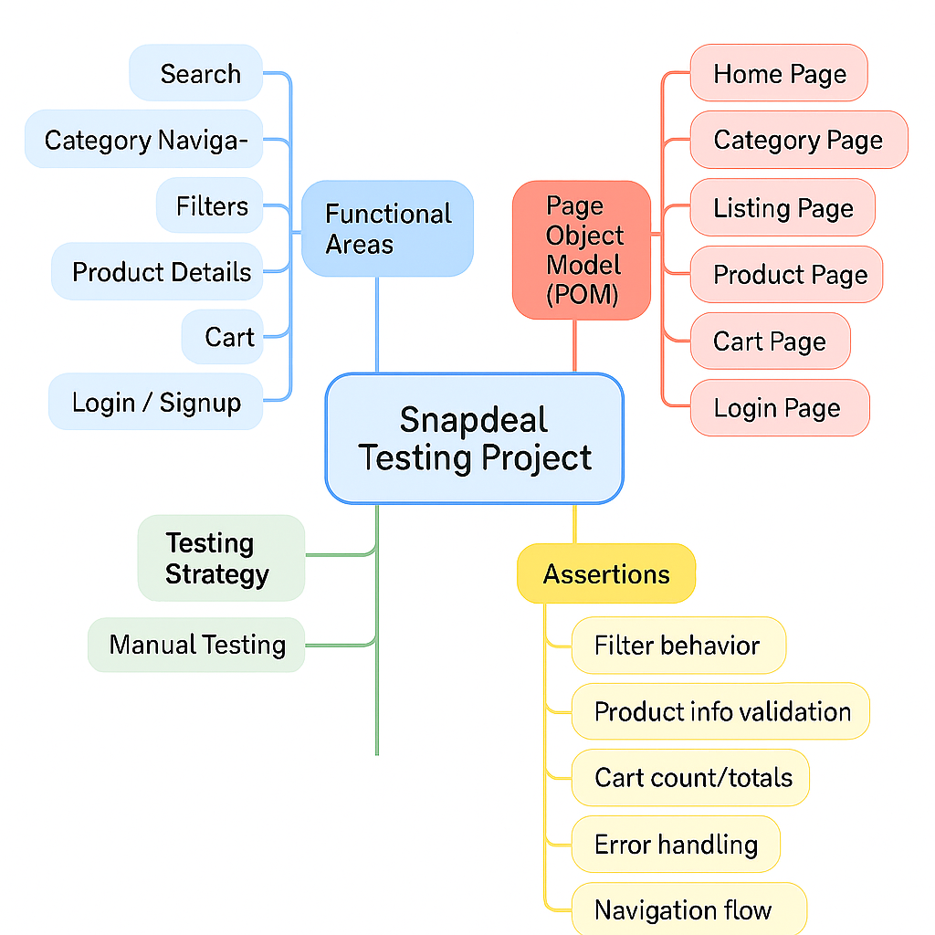

| **Prepared By - Akash Yadav****Date- 11/06/2025** |
| --- |